Fixing UI Design

Created by Tyron Naidoo, Kiran Sompersadh

Follow the styling from the current design paged for consistency

2000 club management

Create an MVC page

Display the total number of Entries in the lottery

A button to view the list of users who entered like their user email or their name

A button to view the list of previous winners their usernames and names

A button to download the data from the 2000 club for the past 3 months

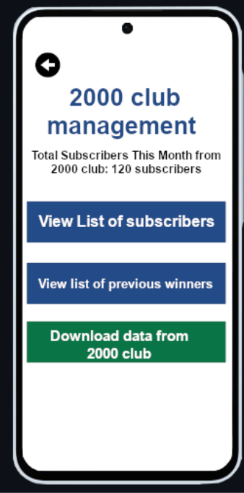

2000 club previous winner’s page

Create MVC page

Display the current winner’s names at the top highlighted for the current month also display classes

Display the past winner’s names below display the classes they won as well

Alter the android page as well to match the mvc

List participant’s page

Create mvc page

Display the list in a table form the user email only

At the bottom add a button to randomly pick the winers

Add a button to redirect to view the list of previous winners

Remove from android

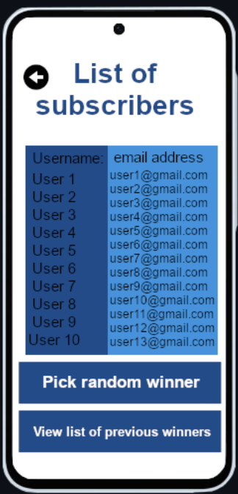

Admin page

Create MVC page

Have a button to manage donations

A button to manage the events taking place

A button to Manage the 2000 club

A button to manage the auction pages

Remove this page from the android app

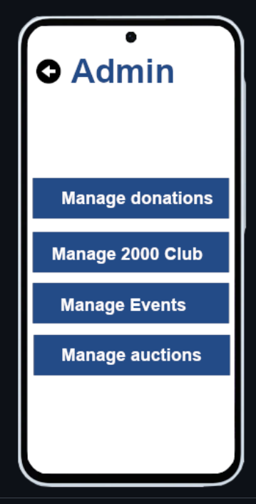

Auction management

Create MVC page

A button to create an auction item

A list of all the auction items in table format

In the table for each item the option to delete and update the items only in mvc

Alter android to use a recycler view to display items

Create individual auction item

Create MVC page

Field to add name of product, description of product price of product and any related images

A button to upload the product

Alter the android page to meet the requirements

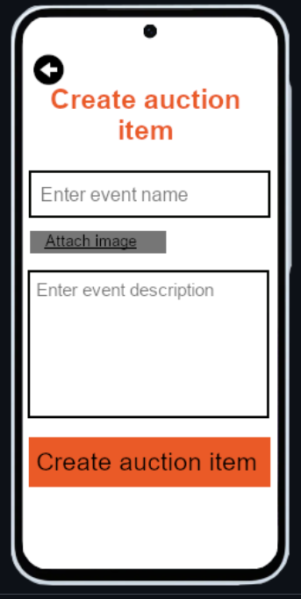

Add auction items page

Create an mvc page that will allow the user to upload multiple items in one csv file

Mvc only

Edit auction item

Create mvc page

Add the fields to edit all the values like name description prise and the picture

Add a button to the bottom to save the changes

Remove from the android app

Event management page

Create MVC page

Add a button to create an event

Display the events in a table format that will have the events listed in rows have a column that has edit and delete. Mvc only

Alter the android app to meet requirements

Display events in a recycler view with relevant information and details

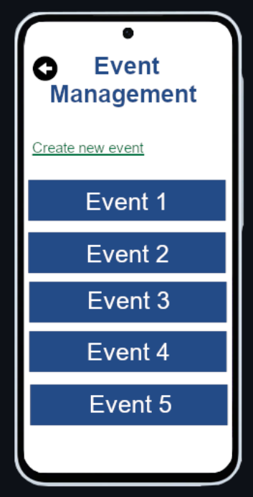

Create event page

Create mvc page

Add a field to enter the event name add a description and attach relevant pictures

Add a button to upload the event

Make changes to the android layout to meet requirements

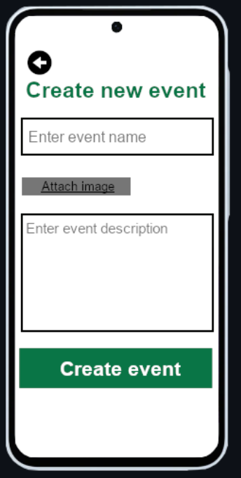

Edit the event page

Create the mvc page

Add the relevant fields name description picture.

Add a button to save the changes

remove from android app

List of doners page

Create mvc page

Display in table format the users email and name and the amount donated

Add a button to download the data in a document

Remove from android app

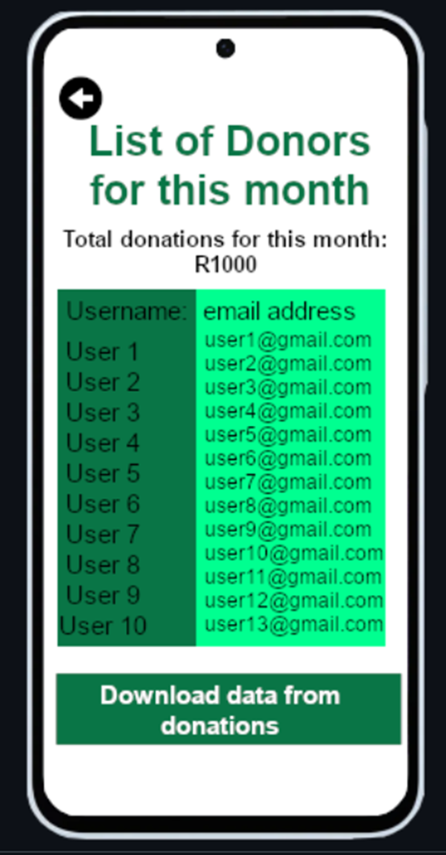

Login page

Create the mvc page

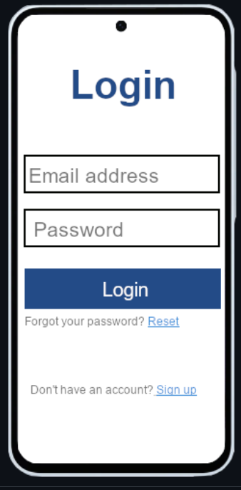

Register page

Create mvc page

Add relevant fields name surname age id password and confirm password

Consult highway about admin registration

View entries in lottery

add android page

display in table format the list of entries a user has incurrent month

add page to android to download tax documents when a donation is made generate a recite